Template email to class charity

This template email is designed for you to send to the chosen class charity after Lesson 2. We recommend making a follow up phone call
as well.

[EMAIL SUBJECT: Our students have chosen to support your charity!]

Dear NAME,

I am writing to you from SCHOOL NAME with an exciting opportunity. Our year X students are currently doing the First Give programme in their X lesson and have chosen to support CHARITY NAME!

Through the First Give programme, our students will be carrying out social action to support you. They will then be competing in a School Final, where one class from the year group will win an additional £1,000 First Give grant for their chosen charity. You can find out more about how First Give works on their website: www.firstgive.co.uk.

The students have chosen your charity because they are passionate about SOCIAL ISSUE. After researching the work you do in our local area, the students will be doing awareness raising and/or fundraising on your behalf.

To improve their chance of winning £1,000 for CHARITY NAME, the students would really like to meet you in their next lesson. The meeting is an opportunity to learn more about the vital work you do, and to get an idea of the kind of social action you would find useful. They will also ask what you would be likely to spend the £1,000 on as this will help them advocate for you in the School Final.

Please find attached the charity guidance document which will give you more detail about the programme.

I do hope that you or a member of the team are able to come into school or arrange an online meeting with the students; please will you contact me on either the email or telephone number provided below and let me know your availability within the next NUMBER weeks. DATE works particularly well for us.

I hope to hear from you soon.

Yours sincerely,

NAME

JOB TITLE
SCHOOL NAME
CONTACT EMAIL
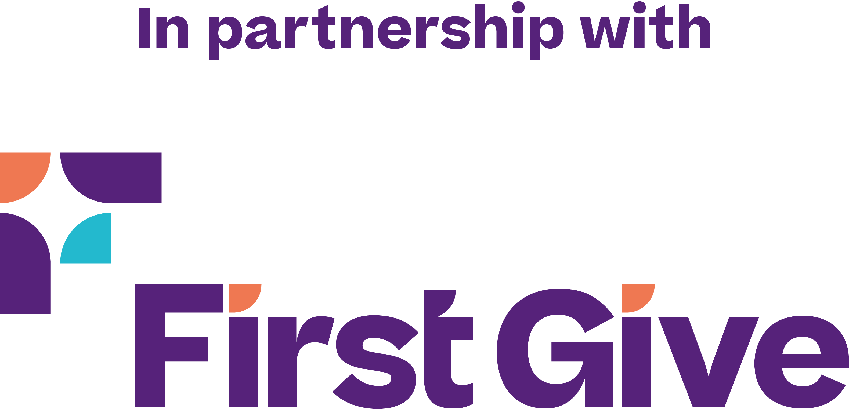
CONTACT NUMBER

