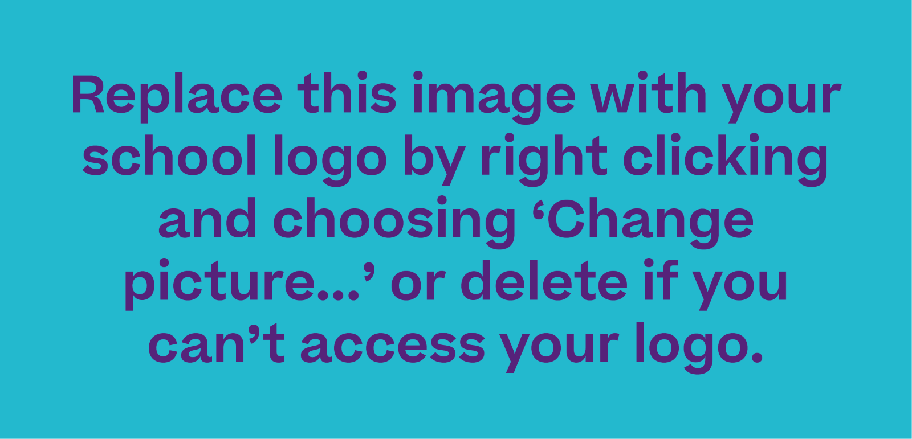

Dear CHARITY NAME/KEY CONTACT NAME,

As a school, and on behalf of our students, we would like to thank you for your recent support and engagement with our students as they went through the First Give Programme!

Your willingness to take the time to meet and talk to our students at SCHOOL NAME has meant that they have been able to further their understanding of local charities’ work and social issues, which we hope has ignited a spark of social conscience in our young people. Interestingly, the top three selected social issues were X, X and X last academic year.

In the 2024/2025 academic year, First Give worked with over 37,270 young people in 208 secondary schools across England and Wales. There were 173 unique winning charities, and this equated to £208,000.00 in First Give grants. Through the First Give Programme, students also raised an incredible £90,000 by engaging in social action projects.

We hope that you had a positive experience while the First Give programme was running at our school. Our students engaged in some creative pieces of social action including X, X and X and I’m delighted to inform you that students at our school raised an additional £X for all their chosen class charities.

First Give know that student engagement is always higher on the programme when they make meaningful connections with their chosen charities; from their surveys, we established that they were 15% more likely to say they enjoyed the First Give programme when they had contact with their charity.

We very much hope that your organisation would be willing to support the school with this project in the future, should you be chosen by the students again.

Best wishes and thank you so much,

NAME, SCHOOL NAME

