THIS TEMPLATE HAS BEEN WRITTEN ASSUMING YOU’VE MET/SPOKEN WITH YOUR CHARITY

Anything to be edited is in yellow highlight

Dear NAME,

Subject: Celebrating year X at SCHOOL: Your chance to win £1,000!

It was so great to meet you on DATE. Thank you for supporting year X with their First Give project. The students learned so much from your presentation, and have been working hard on their social action to support CHARITY.

The students would like to invite you to their School Final, which is the exciting conclusion to their work on the First Give programme, and a celebration of their work and efforts to support you. We hope you’ll be impressed by their dedication and creativity!

At the Final, one class will win a £1,000 First Give grant for the charity they have supported – this could be you! It would be great to see a representative from your charity at the Final to support the students. It adds something really special to the event, especially if you were to win the grant on the day.

Below are the details of the event:

Date:
Time:
Venue:

On behalf of the students, may I thank you for the help you have given them so far. Please confirm your attendance by DATE so we can plan our event accordingly. We hope to see you there!

Yours faithfully,

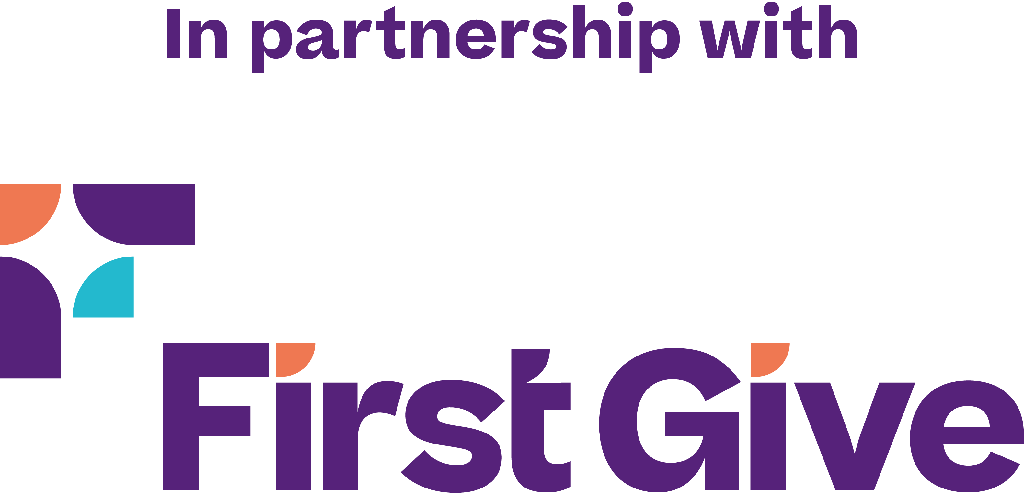
NAME
CONTACT EMAIL/NUMBER

THIS TEMPLATE HAS BEEN WRITTEN FOR CHARITIES YOU HAVE NEITHER MET NOR SPOKEN WITH

Anything to be edited is in yellow highlight

To Whom It May Concern,

Subject: Celebrating year X at SCHOOL: Your chance to win £1,000!

Students in year X at SCHOOL NAME have been working on the First Give Programme, where they have identified social issues in their community, selected a charity that works to support or tackle that issue and engaged in social action to raise awareness or funds for the charity. The students have been creating 5-minute presentations to report on their research and social action. They are competing to win the £1,000 grant at the First Give Final for their charity.

As CHARITY was one of the chosen class charities, the students would love to invite you to join us at the students’ First Give Final. The Final is the exciting conclusion to their work on the First Give programme, and a celebration of their work and efforts to support you. We hope you’ll be impressed by their dedication and creativity!

At the Final, one class will win a £1,000 First Give grant for the charity they have supported – this could be you! It would be great to see a representative from your charity at the Final to support the students. It adds something really special to the event, especially if you were to win the grant on the day.

Below are the details of the event:

Date:
Time:
Venue:

On behalf of the students, may I thank you for the help you have given them so far. Please confirm your attendance by DATE so we can plan our event accordingly. We hope to see you there!

Yours faithfully,
NAME
CONTACT EMAIL/NUMBER

