Dear CHARITY NAME/DIRECTOR NAME/KEY CONTACT NAME,

As a school and on behalf of our students, we would like to thank you for your recent support and engagement as our students went through the First Give Programme!

Your willingness to take the time to meet and talk to our students has meant that they have been able to further their understanding of local charities’ work and social issues, which we hope has ignited a spark of social conscience in our young people.

We hope that you have had a positive experience while the First Give Programme has been running at our school.

The lead teacher of First Give at the school, NAME, will be in touch to arrange transfer of any money that the students raised for your charity. You can contact them on PHONE NUMBER.

We very much hope that your organisation would be willing to support the school with this project in the future, should you be chosen by the students again.

Best wishes,

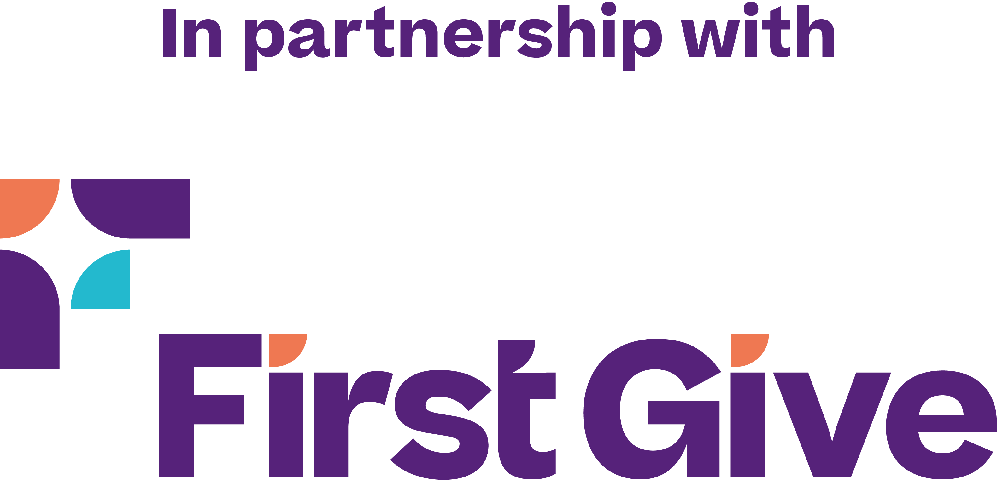
NAME, SCHOOL NAME

